My Goals for English
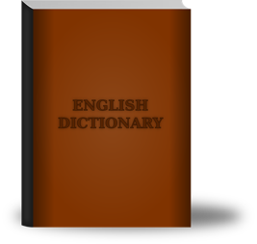
English is a language that has 6,000 years of history. As a student who does not have English as the first language, I want to learn how to do writings better, and improve my reading skills from the English 10. Firstly, writing is the thing that appears in my mind when learning English, because I can express my thoughts and understandings through writing. However, writing is not an advantage for me. In particular, I need to improve my grammar, so that other people can understand my writing easily and clearly. In the same way, I also need to improve my vocabulary in this semester. To illustrate, diction helps to make my writing and articles more interesting instead of using a bunch of same words and makes people feel boring to look at my writing. Furthermore, another goal is to do better on reading. Reading is a habit that everyone should have and enjoy. I like Reading; however, I only understand the content on surface and my goal is to be able to understand the content deeper and to be able to analyze them. To achieve that, I need to read more and know how to analyze a place of literature.
In conclusion, my goals for this course is to improve my writing and reading skills, and I believe I can have an amazing and fun semester in this course.

