Digital Literacy
Tyler Wright (Soccer)
(Due: November 20, 2019)

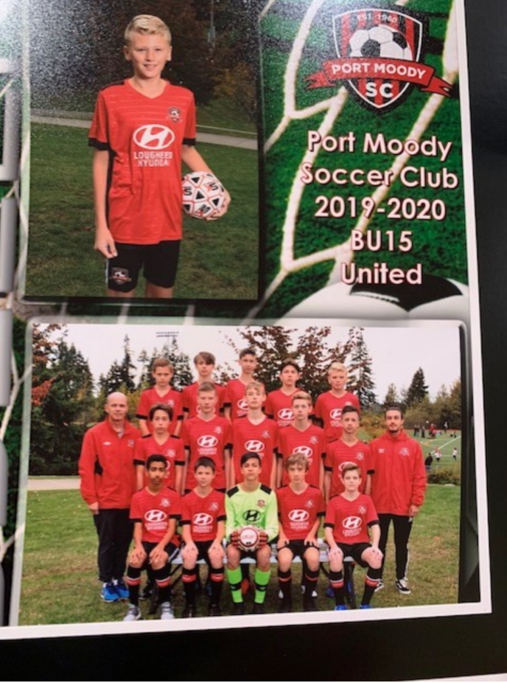
At four years old, my parents introduced me to soccer. I didn’t enjoy the game, and wanted to quit, but my parents said you have to complete the season as you don’t want to let your team down. I remember that I would rather play with my toy trucks than kick around an object. In 2011, that all changed when I was six years old, a lot of my friends played the game, and so I thought I would try soccer again. I not only love playing it, but I love watching the sport and playing Fifa (a soccer game that lets you build your dream team) on my Xbox. This year, I have decided to take it to the next level by referring kids soccer games on weekends (8-10 year old children). I get to see soccer from a referee’s perspective.
I have included this year’s soccer photo - of me and my team. Our team name is Port Moody United, we play division 1. MSL is the top team in the league, we are one down from that. The first position I started to play was “striker”, as every competitive little kid wanted to score goals and that’s all that mattered in a little kid’s point of view. Eventually, my coach started to play me at left and right wing, but I wasn’t as fast as others, so I eventually switched to a full back (right back and left back). I love the position, as I get more freedom on the ball and I also like slide tackling people.
Our team is in a cup final, which we will play either December 15 or the 16th. I have mixed feelings, nervous but excited. The reason I’m nervous is we had a tough time making it into the finals, as we were just kicking the ball out of our half hoping to waste as much time as possible as we were winning by one goal and wanted to make sure they didn’t score.
Soccer is the biggest sport in my life, I eat, sleep and breathe the game. I love everything about it, there are many strategies such as fast build up, long ball, kick and run and possession. I love the connection of the game, as people can get together and talk about the sport for hours on end, such as I do with my friends. Soccer is more than just a game, it connects people.

