Interview Assignment - Tyler Wright

Where Am I Right Now?
I feel that high school is one of the most important times in my life because I'm learning more advanced material to prepare me for my future. I am working really hard at doing my best. Currently, my favorite subjects in school are Social Studies and P.E. The reason I like Socials is because I find it interesting learning more about the past, and having knowledge about the world and society around us. My favourite project from Socials so far was the invention project, where you had to invent something new. I made what's called the "Tech Garage". It was like your normal tech stand on the front but then in the back you could open it up and it was a place to store all your technology or things such as sunglasses, wallets, keys etc... It had LED lights so you could see inside of it. Another cool feature to the Tech Garage is that I put a battery pack on the inside of it, so you could charge your device while you watch it on the front stand. I like P.E because it teaches me the importance of staying healthy, and I enjoy the variety of sports we learn and play. My favourite sports I've played in P.E so far were soccer because I've loved playing it all my life. As well, we played Lacrosse. Since my soccer is so demanding, I had to quit lacrosse, but enjoyed playing lacrosse in P.E. Ultimate Frisbee was surprisingly super fun as I got so many assist's and helped our team win. Outside of school, I play soccer 3 days a week. I not only play soccer but also love watching it and playing FIFA soccer on x-box. I look forward to 4 more years of learning experience, friendships and fun at Heritage Woods Secondary.
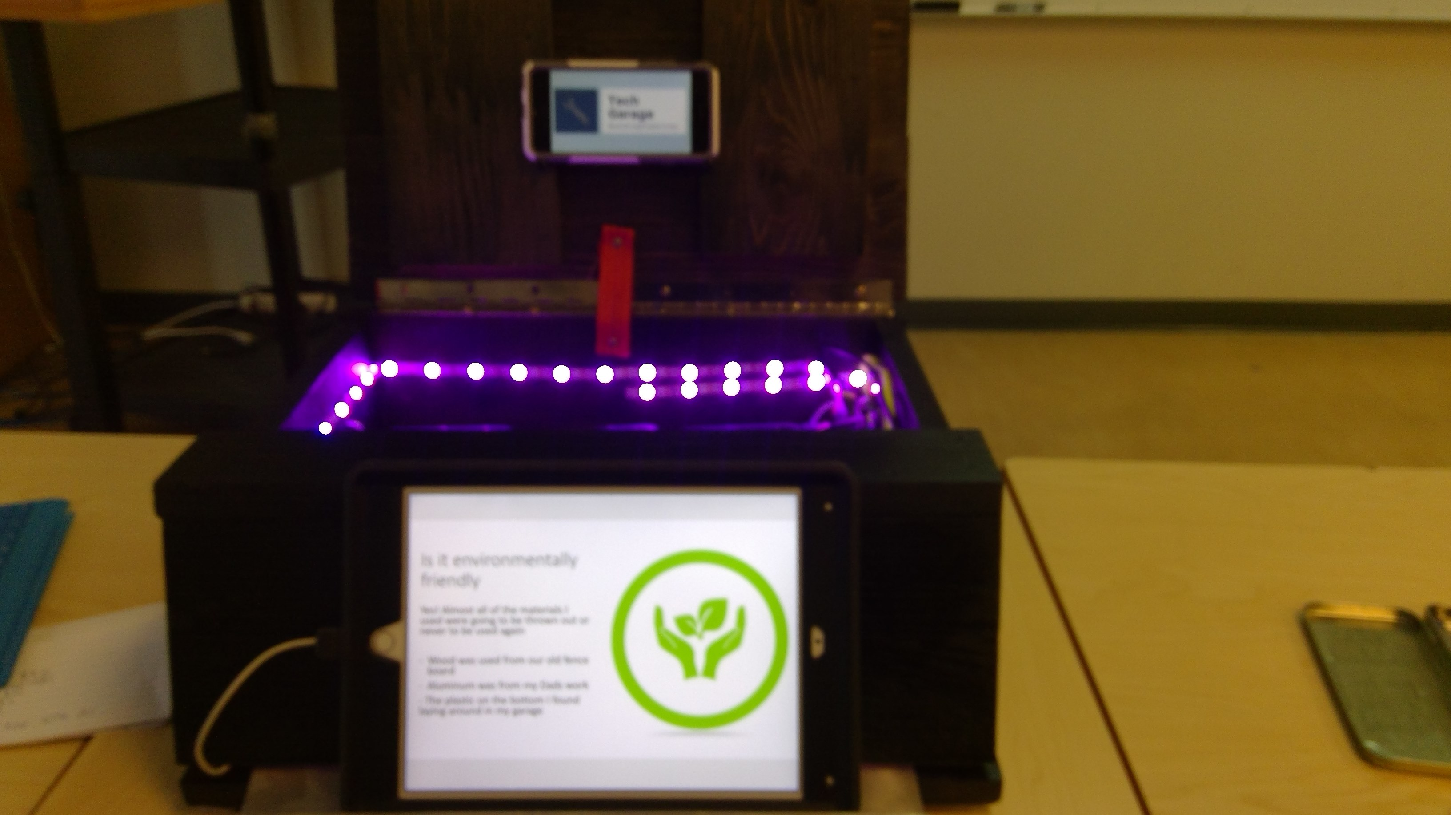
1 - This is the Tech Garage that I described above in my Socials Section.
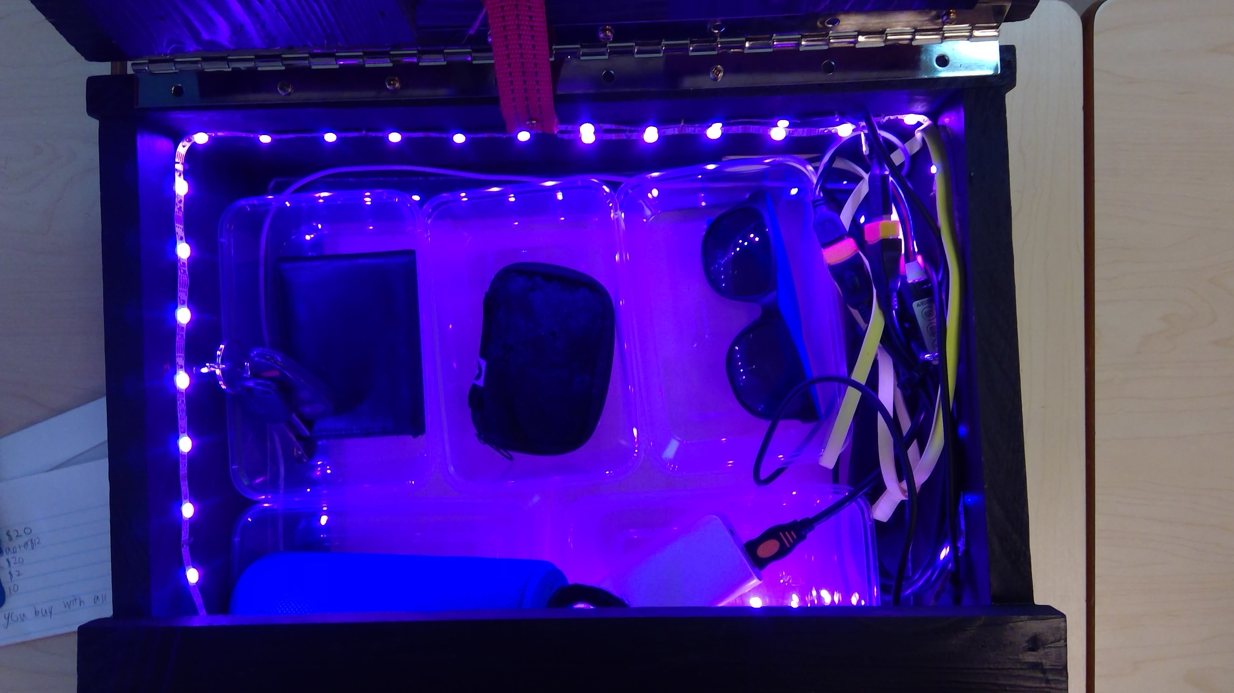
2 - This picture shows the inside of the Tech garage, which took me a total of approximately 7 hours to build.

Where do I want to be in 4 years after I graduate from HWSS?
I found "Take Your Child To Work Day" was valuable as I got an opportunity to see inside a work place, plus met with a variety of departments to see which career path might be of interest. I had the opportunity to meet and learn with 5 different departments which included I.T., Logistics, Communication, Safety and Response Readiness. I wish the Accounting department was available that day, as that was one department that I would have liked to have learned more about, as I like working with numbers. In the next few years I would like to do informational interviews with career professionals in Accounting, Structural Engineering and possibly a P.E teacher to learn more about their professions and if it would be a good fit for me. While I'm not exactly sure what career path I will take, I know my education and doing my best is important.

How can I use some of the skills you've learned this year to help you get to where you want to be in 4 years from now?
While in school these are some of the skills I have learnt that can be used in the workplace:
- team work ability
- communication skills
- working with technology
- use of Microsoft office - Word, PowerPoint, Sway, One note, Teams and Outlook
- meeting deadlines for projects
- working with numbers
- working independently
Team work ability would be useful in an office because if you don't know how to work as a team you might get fired. communication skills would be useful as you could speak to people with confidence. working with technology would be useful in many offices because technology is rapidly and is now a necessary in most offices. most offices require you to use one of these Word, PowerPoint, Sway, One note, Teams and Outlook and I know how to use them all. in offices you need to hand projects in on time or you would get in trouble and possibly get fired. If you work in an accounting department you need to know how to work with numbers otherwise that wouldn't be the right fit for a job, I love working with numbers so it would be a perfect fit. I work independently all the time and its a skill I've always had. All these skills would be useful in a workplace and I will continue to build on them in the next 4 years.

