Synopsis  Jonathon Harker is called to help a man in Transylvania to move to London, little does he know it might lead to his fate. Little while after back in London mysterios events are taking place, soon they find out what true meaning behind the events are, and set out to destroy it. Can they do what they threw everything aside for, will they kill or be killed? |  |  | Author  Bram Stoker is a world renown author, he brought the world the vampire which sparked many movies, books and other ideas to today’s modern life. This book was so good that he has an award handed out under his name annually every year, the Bram Stoker award. Overall Bram Stoker is a phenomenal writer who surpasses all expectations of the reader.  Setting  The setting in the book Dracula first takes place in the late 1800’s in the middle of dark forest in Transylvania, where all the locals dare not to go. As the story moves on it takes place in London, near a port where everything is beautiful and life is going well until Dracula showed up. |  |  | Characters  - Protagonist - The protagonist is an older fellow, who is trained in uncommon diseases by the name of Van Helsing.  Antagonist – In this story the antagonist is a blood sucking vampire named Dracula. He can turn into mist, wolves, and bats, and comes to hunt at night.  v  Other characters – There is many who assist Van Helsing in his duty to rid the world of the vampire. Dr. Seward is one of them he works with someone who is intertwined with the vampire, also there Jonathan Harker and his wife who both have had encounters with the Dracula.

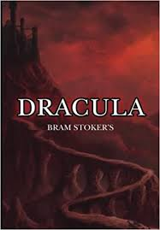  Significant Events  There are several significant events in Dracula, the first being when Ms. Lucy died. Ms. Lucy was the first to die to Dracula, this sent everyone who knew and loved her on a mission to kill Dracula or be killed. Another significant event occurred when they were forced to kill Ms. Lucy as she had turned into a vampire and was killing children. This was important because it confirmed everyone’s suspicions that vampires weren’t or were real. Another significant event was when Dracula moved back to his home in Transylvania. This was important because it showed the first time Dracula was losing and had to retreat, and where the final battle begun.  F |  |  | Writing Style  The whole book is written in journal form, this gives the story a different, interesting view. When a character writes in their journal you understand how much they know, who they know, and what they stand for. I liked this because not many books are written in this format, and it gives it an edge of mystery of the character’s journal you don’t get to read. Overall this is a wonderful way to tell this story, it always leaves the variable of horror, mystery, and suspicion.  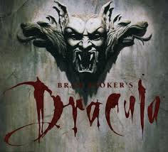 |  |  | Dracula  Bram Stoker - Author  Bram stoker is world renown writer, who has a unique but effective way of telling a story.  Archibald Constable – Publisher  Archibald was a publisher, bookseller, and stationer in the 1800’s.

