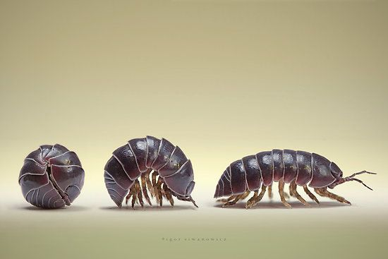
What do wood bugs prefer?
Lemons or maple syrup?
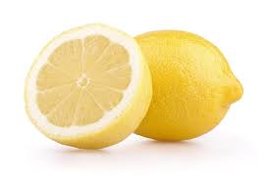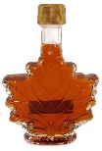

Wood bugs
Where do wood bugs live?
They live in damp and wet areas like under logs, Rocks, piles of wet leaves compost and garbage. Wood bugs are the only crustaceans that live on land unlike lobster, crab and shrimp. Wood bugs don’t bite and are harmless to humans because they fear us. Their shape is like an oval and can roll up into a sphere. They have lots of name like rollie pollies, wood bugs, wood louses, sowbugs or pill bugs. Their species is Armadillidium vulgare and they won’t give diseases or contaminate your food. You can prevent having wood bugs in your house keep your homes by having your house clean and dry because wood bugs don’t like dry places. 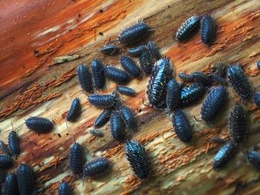
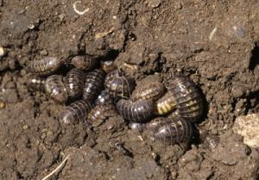
Hypothesis
If we put maple syrup and lemon juice next to the wood bugs, then the wood bugs will go to the maple syrup because it is sweet.
Materials
-Lemon
-Maple syrup
-Box approximately 2x1x1 feet
-Dishes for foods
-7 Wood bugs
-Tape

Procedure
- Tape the corners of the box so the bugs can’t escape.
- Draw a line down the center
- Tape down the dishes, one on each end.
- Put the lemon juice and maple syrup in the dishes.
- Get one bug at a time and let it roam around for 2 minutes.
- Record how long the wood bug at for each half of the box and the side it stayed at is one it liked more.
- Repeat steps 2 and 3 until you run out of bugs
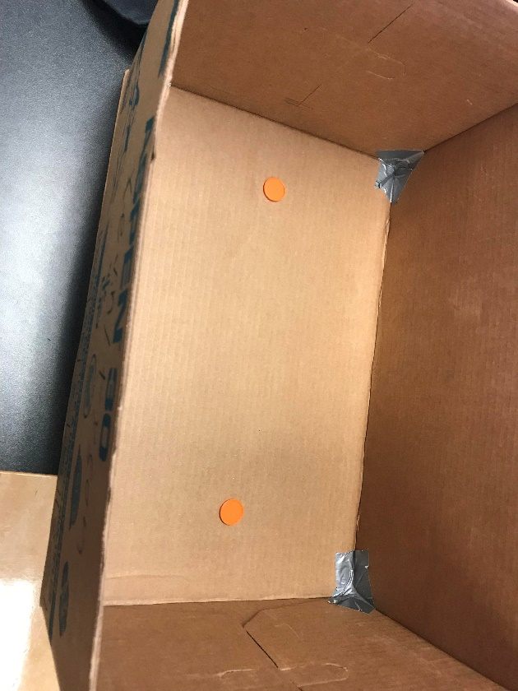

Quantitative Data
How long did each bug stay at each food source?

Seconds Seconds

Qualitative Data
They walked around the box and spent a little more time at maple syrup
Some bugs just stayed in one spot
2 bugs tried to escape from the box

Data Analysis

Conclusion
In conclusion, the wood bugs did not seem to have a preference or didn’t see it and they went to the maple syrup a bit longer by chance. There were 3 bugs that tried to escape and 2 that just sat down in one spot and the rest did not seem to care. We also had 2 type of wood bugs on accident therefore that could affect the experiment. I recommend reproducing this experiment and using one type of woodbug.

References
https://animals.mom.me/background-information-pill-bugs-4459.html
https://pestworldforkids.org/pest-guide/pill-bugs/

Images
https://www.google.com/search?safe=strict&rlz=1C1CHBF_enCA793CA793&biw=1536&bih=722&tbm=isch&sxsrf=ACYBGNRZ371aAcfzQKNp6vXK2VJX9N9bTQ%3A1568220955696&sa=1&ei=Gyd5XY2BKtjC-gShur6oDQ&q=rolly+polly+bugs&oq=roll&gs_l=img.1.0.0i67l4j0l6.15559.16497..18813...0.0..0.66.247.4......0....1..gws-wiz-img.......35i39.HEPbh2ib33Y#imgrc=wBGRJgwW4oC-oM:

https://www.google.com/search?q=maple+syrup&safe=strict&rlz=1C1CHBF_enCA793CA793&sxsrf=ACYBGNS_uwo7uXPBtj6OBZ6VZG0zagOcqw:1568221096159&source=lnms&tbm=isch&sa=X&ved=0ahUKEwjUqvbqnsnkAhWT_J4KHXaJANYQ_AUIEigB&biw=1536&bih=722#imgrc=kRDpbtHR0x97sM:

https://www.google.com/search?q=wood+bugs+natural+habitat&safe=strict&rlz=1C1CHBF_enCA793CA793&sxsrf=ACYBGNTPNInRqIdYLfdb-b054NM7wjX4Cg:1568306033815&source=lnms&tbm=isch&sa=X&ved=0ahUKEwi5sq2g28vkAhXZJjQIHaGWDCQQ_AUIEigB&biw=1536&bih=722&dpr=1.25#imgrc=S82Zb9vvjgGGTM:
https://www.google.com/search?q=wood+bugs+natural+habitat&safe=strict&rlz=1C1CHBF_enCA793CA793&sxsrf=ACYBGNTPNInRqIdYLfdb-b054NM7wjX4Cg:1568306033815&source=lnms&tbm=isch&sa=X&ved=0ahUKEwi5sq2g28vkAhXZJjQIHaGWDCQQ_AUIEigB&biw=1536&bih=722&dpr=1.25#imgrc=fFhRcsyQ3UY9_M:

