Wood bugs
brightness or not
names: Sima Moshfeghi
Yuhan Wang
Folisa Liu
Hypothesis: wood bugs like dark more than others, so if we colored one side with a bright colour, then the wood bug will go to the other side.
Materials are:
-wood bugs
- papers
-neon highlighter
-twisters
-scissors
Procedure :
1-First we got the paper.
2-Folded it edges (so that the wood bugs can't escape).
3-Color the edge neon yellow and leave the other side blank.
4-Put the wood bugs in.
5- wait to see were the would bugs will go.
data
 | Wood bug 1 | Wood bug 2 | Wood bug 3 | Wood bug 4 | Wood bug 5 | total
Went to the bright side | 1 | 0 | 0 | 1 | 1 | 3
Went to the blank side | 0 | 1 | 1 | 0 | 0 | 2

Qualitative observation:
- they are brown and black.
- they are around like 1.5 cm.
- they have many feet.
- their cases are hard.

Data analysis
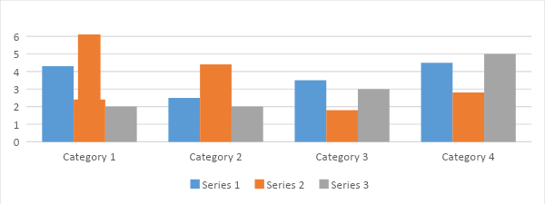
Conclusion : (all three parts)
1.We are right at the hypothesis, the wood bugs like dark side.
2.Maybe the wood bugs are tired, or they just go by accident, because there are 3 go to the dark side and 2 go to the colour side. That is pretty close.
3.We will want to try 5 to 10 wood bugs and try different colours to do the experiment again.

